Language Support in MS Teams
Contents
Language Support in MS Teams 1
Live Captioning 2
How to turn it on 2
Translation 4
How to start translating your Teams meeting 5
Via your PC 5
Via your mobile device 8
How to access the meeting translation as a meeting attendee 11
Via your PC 11
Via your mobile device 13

Live Captioning
All meeting attendees have the option to turn on live captions. This only affects them, rather than turning it on for everyone. This can be useful if you have a hearing impairment and need captions to assist your understanding of the meeting. Live captioning is not perfect, but if everyone speaks clearly it is fairly accurate.

How to turn it on
You can’t turn this on across the board so it will need to be turned on when you join a meeting. Everyone who wants to view live captions will need to turn it on individually.
- Click on the … in the floating menu and choose ‘Turn on live captions (preview, English US only)’ from the menu that appears:

- Captions will now appear at the bottom left of your screen as you or anyone else in the meeting speaks.
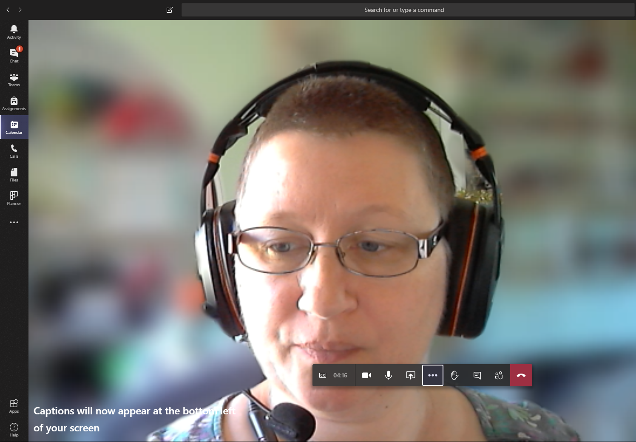

Translation
Live captions are only available in English currently, but it is possible to have conversations translated from English to Welsh (or other languages) using Microsoft Translator.
The meeting owner will need to start a conversation in Microsoft Translator, and give attendees a link to the conversation. The attendees can then specify what language they want to use and when the presenter talks, they’ll get the translation via this conversation. Some languages have audio translation, but Welsh currently only has text translation.
Unfortunately, it is not possible to use Microsoft Translator the other way around and translate speech from Welsh to English, as Welsh is only included as a textual language. If this was important you would need to have someone on hand who could type the Welsh into the conversation while the speaker was speaking. Typed Welsh text in the conversation would then be translated to the language that attendees have chosen.

How to start translating your Teams meeting
Note: You’ll need to set this up immediately prior to the meeting, not far in advance. The conversation only exists while you are in it.

Via your PC
- Go to https://translator.microsoft.com/.
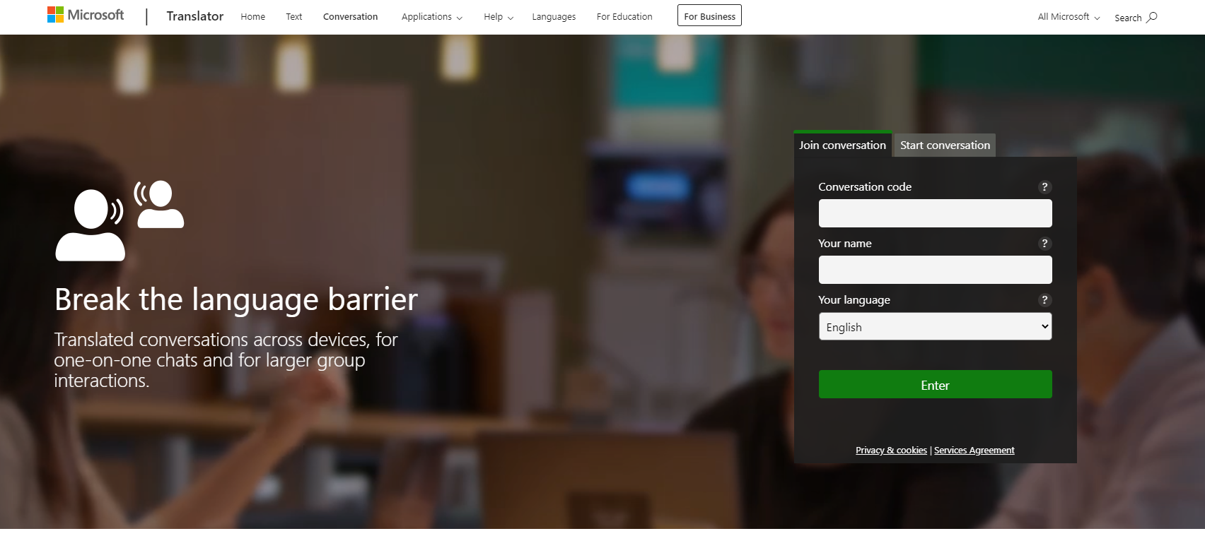
- Click on the ‘Start conversation’ tab:
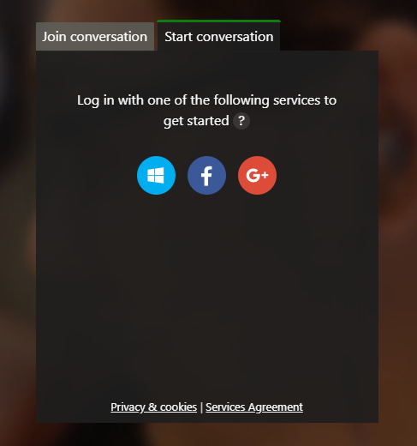
- Click on the Microsoft icon (white window on blue circle).
- Log in with your usual AU email address and password.

- You’ll now be asked to give your name and what language you wish to see/hear (set this to your own language):
- Click the Enter button.
- You’ll now be asked to check your devices and may need to allow Microsoft Translator to access them:
- You’ll now enter your conversation screen:
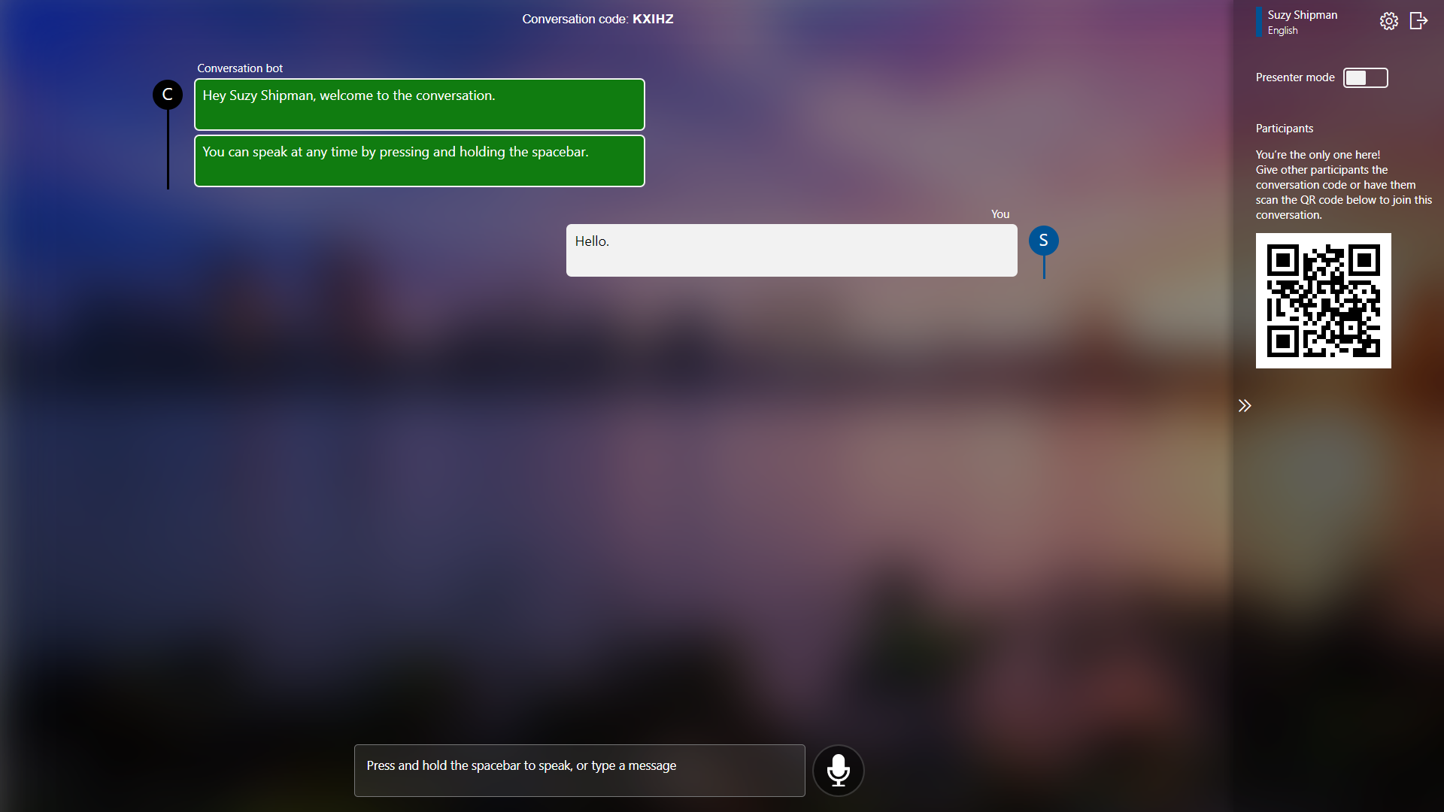
- Turn on ‘Presenter mode’ at the top right of the screen (so you won’t have to press the spacebar while talking) and keep a note of your conversation code (visible at the top centre of the screen).
- Leave your browser open and switch to your Teams app.
- Inform meeting attendees that they can have the meeting translated, by using Microsoft Translate and give them the conversation code so that they can join.
- Once everyone has joined the conversation, proceed with your meeting as normal, making sure to speak clearly and not too fast.

Via your mobile device
Note: if you are using Microsoft Translator on your mobile device, you’ll need to use a different device to run Teams.
- Open the Microsoft Translator app on your mobile device:
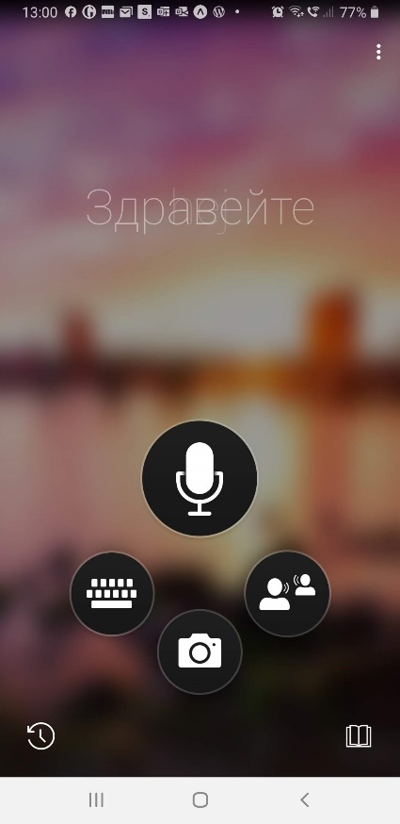
- Click on the conversation icon (two people icon, on the right) and you will see the conversation screen:
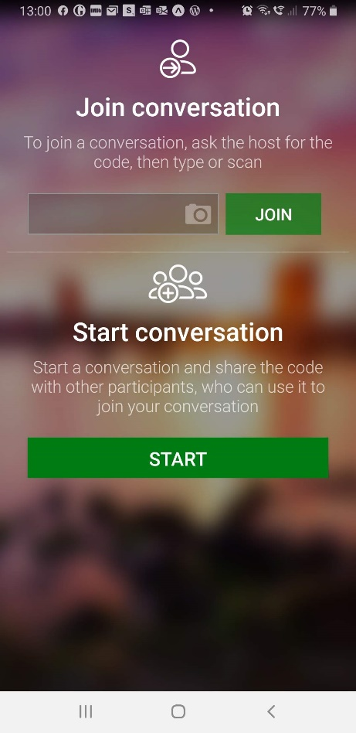
- Click on the ‘START’ button in the ‘Start conversation’ area.
- You will now be asked to give your name and choose your language:
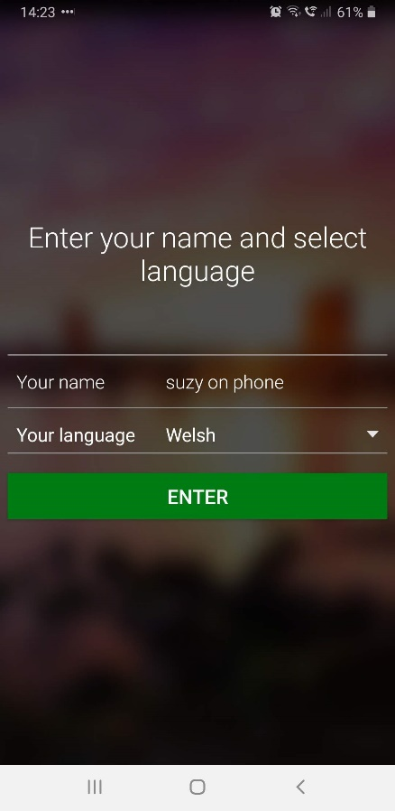
- Click the Enter button and make a note of the code given to you on the next screen:
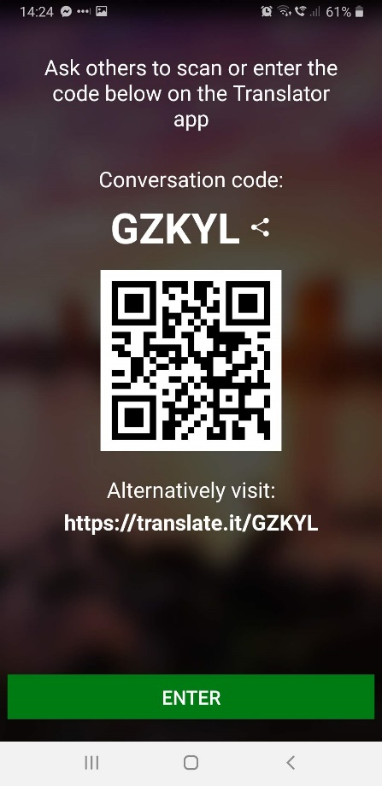
- Click the Enter button to start the conversation.
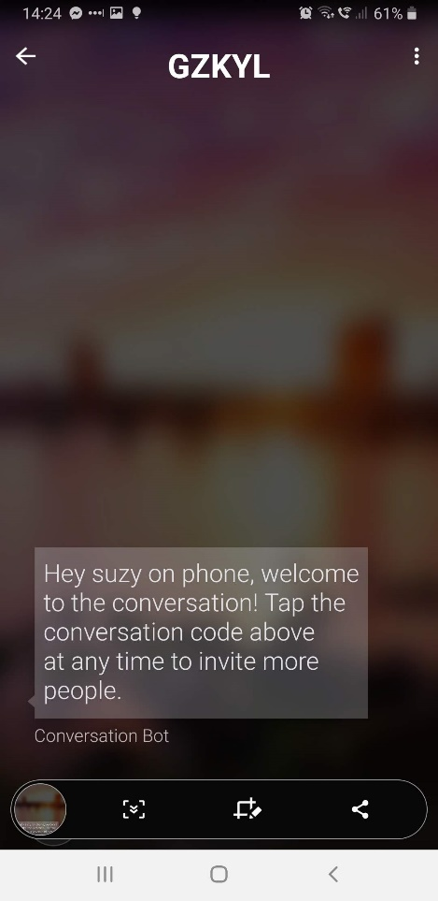
- Leave the app open and go to your Teams app on your PC or other device (not on the same device where you are using the Microsoft Translator app).
- Inform meeting attendees that they can have the meeting translated, by using Microsoft Translator and give them the conversation code so that they can join.
- Once everyone has joined the conversation, proceed with your meeting as normal, making sure to speak clearly and not too fast.

How to access the meeting translation as a meeting attendee

Via your PC
- Make a note of the conversation code you have been given
- Go to https://translator.microsoft.com/
- Type or paste your conversation code into the Conversation code box, add your name, and select the language you wish to view/hear.
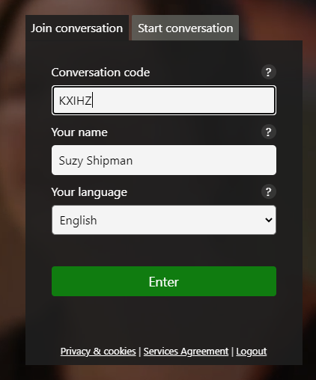
- Click the Enter button

- You will now see the conversation screen:
- To keep this conversation window and your Teams window on screen together you can use Windows button + left arrow or Windows button + right arrow to arrange your windows.
- Proceed with your meeting and you should see the presenter’s speech translated for you in your conversation window.
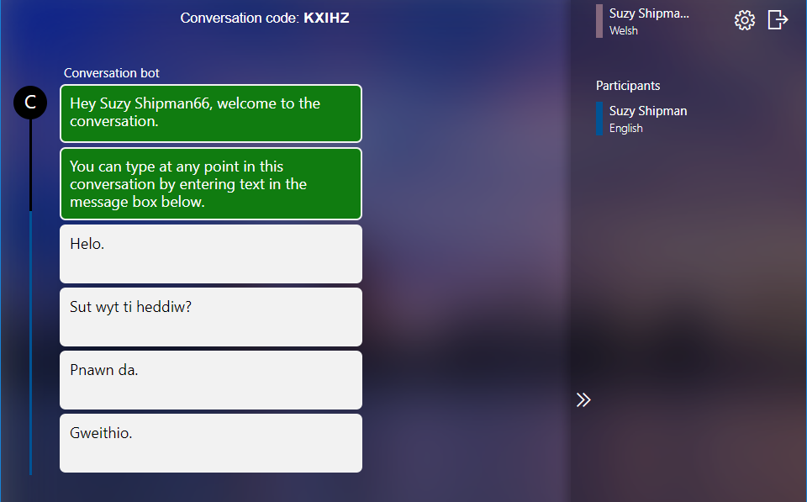

Via your mobile device
- Open the Translator app on your mobile device:
- Click on the conversation icon (two people icon, on the right) and you will see the conversation screen:

- Type or paste the conversation code in the ‘Join conversation’ area and click the ‘JOIN’ button. You will now be asked to give your name and choose your language:
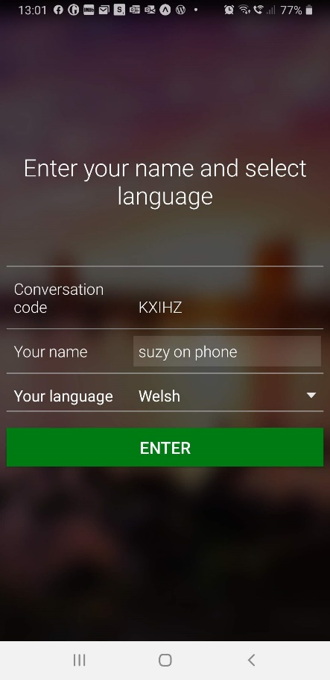
- Click the Enter button to join the conversation.
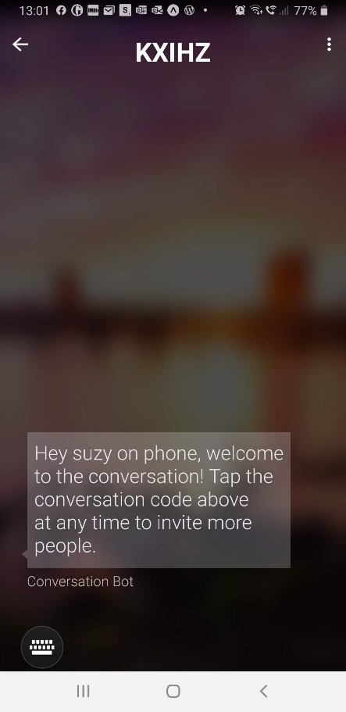

- Proceed with your meeting and you should see the presenter’s speech translated for you in your conversation screen:
