Online Meetings with Microsoft Teams
You can have online meeting through Teams. This is very useful if you are working with people across the university or if team members are not currently on campus. Meetings are similar to Skype calls.
Online Meetings with Microsoft Teams 1
Requirements 3
Remote Desktop: 3
Essential items: 3
Optional items 3
Testing 4
Creating an Online Meeting 6
Schedule a Meeting 6
From your Outlook Calendar 6
From your Teams Calendar 7
From Chat 8
From a Channel 9
Change Meeting Settings 10
Permission levels 12
Recommended Permissions 12
Meeting Security 13
Start a Meeting Now 14
From Calls 14
From Chat 15
From a Channel 16
Taking Part in an Online Meeting 17
Menu 17
Audio & Video 17
Screen sharing 18
Background Effects 19
Recording the meeting 21
Raise Hand 22
Text chat 22
Add people 22

Requirements

Remote Desktop:
If you are using Teams via remote desktop, you will need to make sure you change the default settings to allow your work PC to access the devices attached to your home PC. See https://www.aber.ac.uk/en/media/departmental/web/Remote-Desktop-for-Teams.pdf for more details of what settings to use.
You may find it works better to run Teams on your home PC and use your remote PC for everything else.

Essential items:
- Microphone – in order to share audio of yourself with the other people in the call you will need a microphone.
- Speakers or headphones – in order to hear audio from the other people in the call you will need either speakers or headphones. Headphones are preferred as you can have issues with feedback if you are using speakers.
- Headset – a headset can be used as an alternative to a microphone and headphones as it has a built-in microphone.

Optional items
- Webcam – in order to share video of yourself with the other people in the call, you will need a webcam. This is not needed if you are only having an audio call, and you can still screenshare without one.

Testing
You can test your setup before taking part in call by running a test call:
- Click on the picture of yourself (or your initials) at the top right corner of the screen.
- Choose ‘Settings’ from the menu that appears.
- Click on ‘Devices’ in the left menu of the settings window.
- Check the devices shown are the ones you want to use.
- Click the ‘Make a test call’ button.
- Record a message after the beep as requested and check that you can hear it played back to you.
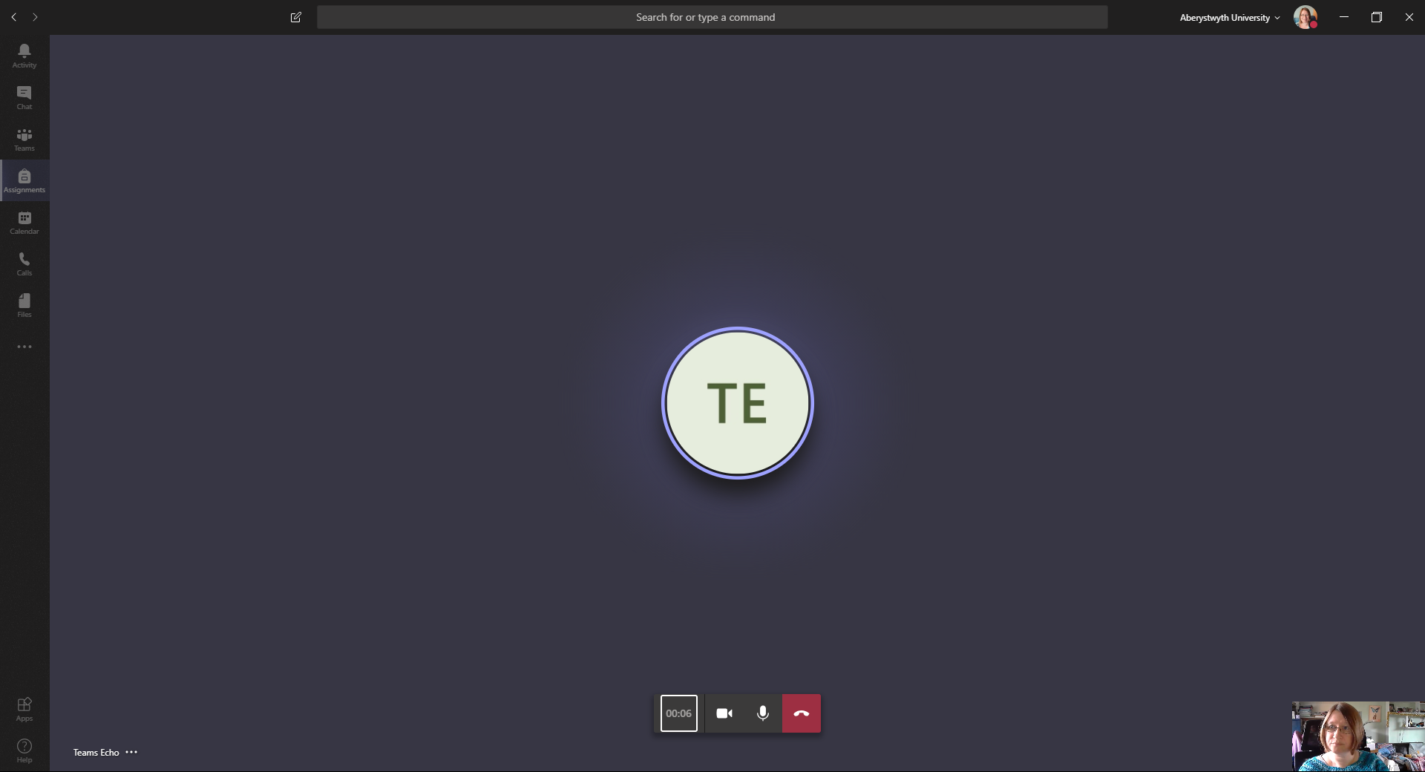
- When the test call ends it will display the results including microphone, speaker, camera and network. If any problems are found, you will need to check your device settings

Creating an Online Meeting
To create an online meeting you should begin by scheduling it, and once that has been done, you’ll need to return to the meeting to update meeting settings.

Schedule a Meeting

From your Outlook Calendar
- Double-click on the calendar, on the date and time you want to have the meeting.
- The ‘Appointment’ screen appears.
- Click on the ‘Teams Meeting’ button at the top of the screen.
- You’ll now see the standard ‘Join Microsoft Teams Meeting’ text showing on the screen
- Give your meeting a Subject.
- Add required attendees by typing their names or usernames in the ‘To’ box.
- The date and time of the meeting should already be set, but if it’s not correct you can edit it. If you need to check for a good time for the meeting, click on ‘Scheduling Assistant’ at the top of the screen, as you would for a ‘normal’ meeting.
- Add details of the meeting in the large box at the bottom. Don’t remove the joining link and options that have already been put in for you.
- Click Send to send the meeting invitation.
Note: you can create your meeting in Outlook in whatever way you would usually create it. You just need to remember to click on the Teams Meeting button as noted.

From your Teams Calendar
- Click on the Calendar icon in the left menu.
- Click on the calendar, on the date and time you want to have the meeting.
- The ‘New meeting’ screen appears.
- Give your meeting a title.
- Add required attendees by typing their names or usernames in the ‘Add required attendees’ box.
- If you would like to add optional attendees, click on ‘+ Optional’ at the right-hand end of the ‘Add required attendees’ box. A new box will appear for you to add the optional attendees.
- The date and time of the meeting should already be set, but if it’s not correct you can edit it. If you need to check for a good time for the meeting, click on ‘Scheduling Assistant’ at the top of the screen. This works just like Outlook.
- Choose a channel from ‘Add channel’ if required.
- Add details of the meeting in the large box at the bottom.
- Click Save to finish.

From Chat
- Click on the Chat icon in the left menu.
- Select an existing chat or create a new one.
- Click on the ‘Schedule a meeting’ icon (calendar) underneath the ‘Type a new message’ box.
- The ‘New meeting’ screen appears.
- Give your meeting a title.
- Add any extra attendees if required (it should automatically include the people currently in the chat).
- Choose a date and time for the meeting. If you need to check for a good time for the meeting, click on ‘Scheduling Assistant’ at the top of the screen. This works just like Outlook.
- Choose a channel from ‘Add channel’ if required.
- Add details of the meeting in the large box at the bottom.

From a Channel
- Click on the Teams icon in the left menu.
- If you already have a Team selected, you may need to click the icon again to show all the Teams you are a member of.
- Click on the appropriate Team.
- Click on the appropriate channel (if there is only one channel it will be automatically selected).
- Click on the ‘Meet Now’ icon underneath the ‘Start a new conversation’ box.
- A black box will pop up asking for more details.
- Click on ‘Schedule a meeting’ beneath the ‘Meet now’ button.
- The ‘New meeting’ screen appears.
- Give your meeting a title (if you already gave it a title before clicking ‘Schedule a meeting’, this will already be displayed).
- Add required attendees by typing their names or usernames in the ‘Add required attendees’ box.
- If you would like to add optional attendees, click on ‘+ Optional’ at the right-hand end of the ‘Add required attendees’ box. A new box will appear for you to add the optional attendees.
- Choose a date and time for the meeting. If you need to check for a good time for the meeting, click on ‘Scheduling Assistant’ at the top of the screen. This works just like Outlook.
- The channel you are in should be automatically selected.
- Add details of the meeting in the large box at the bottom.

Change Meeting Settings
After creating and saving your meeting, you can view additional information about the meeting as well as changing settings for the meeting.
- Click on the Calendar icon in the left menu.
- Find the meeting you have created and click on it.
- You will now see that there are several additional tabs and options at the top of the meeting screen.
  - Chat: allows you to access the chat pane for the meeting. You won’t be able to put any text here until you have joined the meeting. If you want some text to be here from the start of the meeting, you can click the ‘Join’ button now then leave the call when you are done.
  - Files: allows you to access the shared files section for this meeting. You won’t be able to upload any files here until you have joined the meeting. If you want a file to be here from the start of the meeting, you can click the ‘Join’ button now then leave the call when you are done.
  - Meeting notes: allows you to access the meeting notes section for this meeting.
  - Whiteboard: allows you to access the Whiteboard for the meeting where you can write or draw on screen.
- As well as these additional tabs, you can now also access Meeting options.
- Click on Meeting options at the top right or in the large box, under the join link.
- Meeting options will open in your web browser, and you may need to log in.
- In the page that is displayed there are 4 options that you can set:
  - Who can bypass the lobby?: this allows you to set whether or not people have to wait in a virtual lobby until their entry is approved. The default setting is ‘people in my organization’. You can change this to allow people from trusted organizations to also bypass the lobby, or to allow everyone to bypass the lobby.
  - Always let callers bypass the lobby: this is not an option we need to change as we are not set up for callers.
  - Announce when callers join or leave: this is not an option we need to change as we are not set up for callers.
  - Who can present?: this allows you to set what permissions the other people in the meeting have. See the permission levels section for more details on what different levels can do. As you are the meeting organizer you have full organizer permissions. You can restrict the permissions for others by changing the value in the drop-down.
    - Everyone: this is the default and gives all attendees have presenter permissions.
    - People in my organization: this allows every attendee who is from our organisation to have presenter permissions. Other users will have attendee permissions.
    - Specific people: this allows you to choose specific users from the list of participants and give them presenter permissions. Other users will have attendee permissions.
    - Only me: this allows you to specify that you are the only presenter, and all other users will have attendee permissions.
- When you have finished changing settings, click the Save button.

Permission levels
- Organizer and Presenter – users with this level of permission can:
  - speak and share video
  - participate in meeting chat
  - share content
  - privately view a PowerPoint file shared by someone else
  - take control of someone else’s PowerPoint presentation
  - mute other participants
  - remove participants
  - admit people from the lobby
  - change the roles of other participants
  - start or stop recording.
- Attendee – users with this level of permission can:
  - speak and share video
  - participate in meeting chat
  - privately view a PowerPoint file shared by someone else.

Recommended Permissions
If your meeting is intended to be open to anyone, and you want all attendees to be able to participate fully, leave the ‘Who can present?’ option set to the default of ‘Everyone’.
If your meeting requires 2 or more attendees to present, but you don’t want other attendees to be able to present, you should choose ‘Specific People’ and choose those who should be allowed to present.
If your meeting requires only the organiser to present, you should choose ‘Only Me’ so that nobody else can take over the meeting.

Meeting Security
If your meeting is confidential you will need to take additional steps to ensure that only invited users attend the meeting. It is currently not possible to restrict entry to only allow invited users, so it is important to ensure that the join link for the meeting is not made available to uninvited users.
How to achieve this:
- Don’t share the join link with anyone outside of the invited users.
- Ensure that all attendees are aware of the confidential nature of the meeting and the importance of not making the join link available to others.
- Make the meeting private in your Outlook calendar so that people you have shared your calendar with cannot see the meeting details.
- Ask all attendees to also make the meeting private in their Outlook calendars.

Start a Meeting Now

From Calls
- Click on the Calls icon in the left menu.
- In the box under Make a call in the panel on the left, type the name or userid of one of the people you want to meet with.
- Select the correct person from the options that appear.
- The person will now be shown in the box with a X next to them (this X can be used to remove a person if you added them in error).
- Repeat until you have all the people you want to meet with in the box.
- Click the ‘audio call’ or ‘video call’ icon at the bottom of the panel to start the call.
- The people you call will see a notification in Teams and will need to accept the call.

From Chat
This will only work in an active chat where the people you are chatting with are available.
- Click on the Chat icon in the left menu.
- Select an existing chat or create a new one.
- Click on the ‘video call’ or ‘audio call’ icon at the top right of the screen.
- If you just want to share your screen with the person you are chatting with, click on the ‘Start sharing your screen’ icon.
  - Choose what you want to share from the options that appear:
    - Your desktop (or one of your screens if you have more than one.
    - A specific application that is open on your PC.

From a Channel
- Click on the Teams icon in the left menu.
- If you already have a Team selected, you may need to click the icon again to show all the Teams you are a member of.
- Click on the appropriate Team.
- Click on the appropriate channel (if there is only one channel it will be automatically selected).
- Click on the ‘Meet Now’ icon underneath the ‘Start a new conversation’ box.
- A black box will pop up asking for more details.
- If you want to, you can add a subject for the meeting by clicking on ‘Want to add a subject?’ and typing the title.
- If you want to use video turn it on by clicking On beneath the ‘Meet now’ button. This will only be available if you have a webcam available.
- If you want to meet immediately, click the ‘Meet now’ button.
- The members of the channel will all see a notification in Teams and will need to accept the call.

Taking Part in an Online Meeting
Whether a meeting was started by yourself or someone else, or whether it was started from a call, chat or channel, the meeting itself will be the same unless the organizer has changed any settings.

Menu
At the bottom of your screen, you’ll find the floating menu. This will disappear when the meeting screen is not in use – just move your mouse in the Teams window for it to reappear.
Some items in the floating menu may not be available to you if the meeting organiser has set you to be an attendee rather than a presenter.

Audio & Video
During a call you can mute your microphone or turn off your video by clicking the appropriate icon in the floating menu: video camera icon or microphone icon. You’ll see that the icons have a line through them when you have disabled them:

Screen sharing
If you want to share your screen with the other people in the call, click on the ‘Share screen’ icon (icon to the right of the microphone icon, showing a rectangle with an arrow pointing upwards). You can then choose what you want to share, e.g. your desktop, a specific window, a presentation (PowerPoint) or an application. The part of your PC that you are sharing will be highlighted with a red line. If you shift to another application that isn’t being shared, other users won’t be able to see what you are doing. You can stop sharing by clicking on the ‘Stop sharing’ icon in the floating menu.
Note: Screen sharing is only available to organisers or presenters. If the organiser has set you to be an attendee, the share screen option will be greyed out and an explanatory note will show if you put your mouse on the screen sharing icon:

Background Effects
When using video, you may wish to blur your background or use a background image. This is particularly useful if you are in an area with lots of distractions, or you are in a personal space. Click on the … in the floating menu and choose ‘Show background effects’ from the menu that appears:
A panel will open on the right showing your options for your background. This may take some time to fully load. Once it has loaded you can scroll through the background images that are available. You also have the basic ‘blur background’ option at the top. Click on your preferred option. At the bottom of the panel click the ‘Preview’ button to check how your chosen option looks, and then if you are happy with it, click the ‘Apply and turn on video’ button. If you don’t want to preview you can just click the ‘Apply’ button.
The background will be blurred or replaced with the background image you chose. Noted that this is not perfect, but it will help you to avoid having distractions showing in the background.
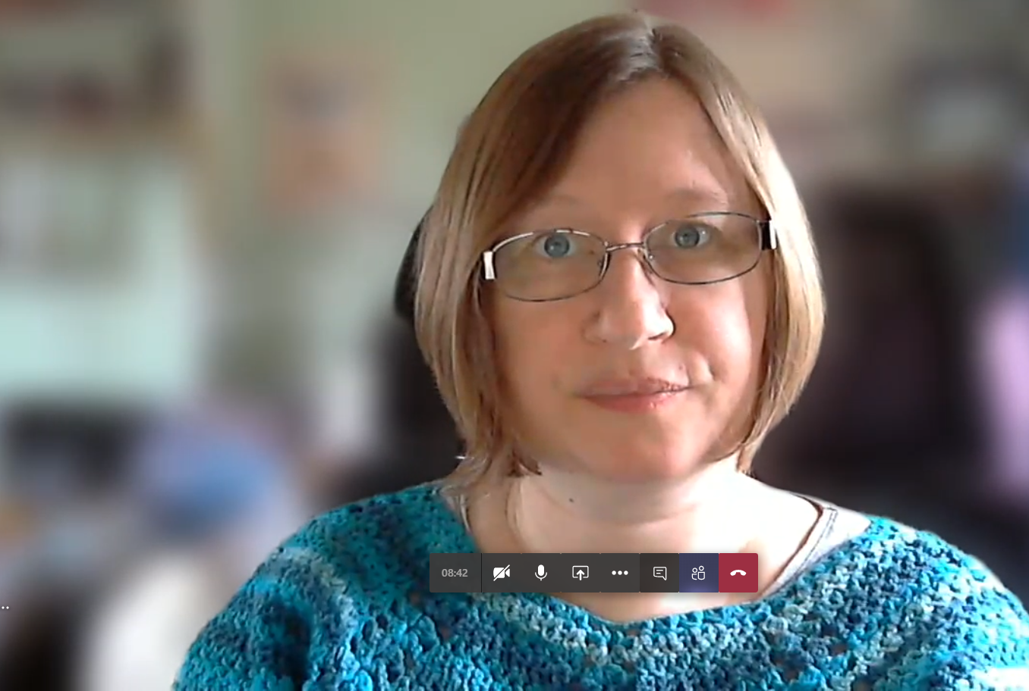
Note: it is possible to add your own background images. Images that are at least 1920 x 1080px can be saved to the following location to be used as backgrounds: C:\Users\your-username\AppData\Roaming\Microsoft\Teams\Backgrounds\Uploads
(Replace highlighted text with your username)

Recording the meeting
Meetings can be recorded so that people who couldn’t attend can catch up later or just to keep a record of what was discussed. Click … and choose ‘Start recording’. To stop recording, click … and choose ‘Stop recording’. The recording of the meeting will be saved to Microsoft Stream and you will be notified when it’s available to watch.
Note: Only organisers or presenters can start recording. If the organiser has set you to be an attendee, the ‘Start recording’ option will be greyed out.

Raise Hand
In a large meeting it is often useful for most users to have the microphones muted while the main presenter is speaking. The raise hand button is a way to let the presenter know that you would like to ask a question or comment. When you click the ‘Raise your hand’ icon, the presenter will be notified and will be able to invite you to contribute when they are ready. You can click the icon again to cancel your raised hand.

Text chat
If you want to use text chat during your online meeting, click on the ‘Show conversation’ icon (speech bubble) in the floating menu to make a chat panel appear on the right of the screen.

Add people
If you want to add more people to the online meeting, click on the ‘Show participants’ icon (people). This will display a panel on the right of the screen showing the users currently in the meeting. To add someone new, type their name or user id in the ‘Invite someone’ box and choose them from the options that appear. They will be notified in Teams and can either accept or decline the call.

